Exercise 1: Implementing the Singleton Pattern
Code:
using System;
public sealed class Logger
{
private static Logger instance;
private Logger()
{
Console.WriteLine("Logger Instance Created");
}
public static Logger GetInstance()
{
if (instance == null)
{
instance = new Logger();
}
return instance;
}
public void Log(string message)
{
Console.WriteLine("LOG: " + message);
}
}
class Program
{
static void Main(string[] args)
{
Logger logger1 = Logger.GetInstance();
Logger logger2 = Logger.GetInstance();
logger1.Log("Application Started");
logger2.Log("User Logged In");
if (logger1 == logger2)
{
Console.WriteLine("Both are the same instance.");
}
else
{
Console.WriteLine("Different instances created.");
}
}
}
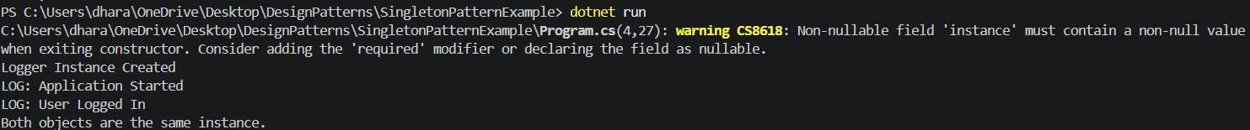
Output:

